

PROJECT REPORT ON

MOBILE-PLAN

**BY, TEAM DEFENDERS**

Surbhit Vishwakarma

Amey Agnihotri

Roshani Pagare

Pratik Mahajan

Aishwarya Gaikwad

**MENTORED BY:**

Arya Raj

**CONTENTS**

|  |  |  |  |
| --- | --- | --- | --- |
| Sr.No. | CHAPTER | | Page No. |
| 1 | Project Title | | *1* |
| 2 | Introduction | | *1* |
| 3 | Details | | *1* |
| 4 | Workflow | | *1* |
| 5 | Planning | | 2 |
| 6 | Implementation | | *4-5* |
|  | a. | For Backend Part | *4* |
|  | b. | For Frontend Part | *5* |
| 7 | Diagrams | | *6-8* |
|  | *A.* | ER Diagram | *6* |
|  | *B.* | Use Case Diagram | *7* |
|  | *C.* | Architectural Diagram | *8* |
| 8 | Screenshots | | *9-12* |

**PROJECT REPORT ON MOBILE-PLAN APPLICATION**

* **PROJECT TITLE:**

Mobile-Plan Web Application

* **INTRODUCTION:**

MOBILE-PLAN is Restful API based application which is developed using Spring Boot Framework. This application is used to perform operations such as create, retrieve, update, and delete on Mobile Plan data.

Technologies and Tools used:

* Frontend:*HTML, CSS, JavaScript.*
* Backend**:** *Spring, MariaDB.*
* ToolsUsed**:** *STS, VS Code, Git, Postman, Docker.*
* **DETAILS:**

Mobile Plan can perform various operations. They are as follows:

|  |  |  |
| --- | --- | --- |
| 1 | Create | This function allows user to add new mobile plans. |
| 2 | Get All | This function allows user to get all the mobile plans. |
| 3 | Search By ID | This function allows user to search the mobile plan by ID. |
| 4 | Update | This function allows user to update the details of mobile plan |
| 5 | Delete | This function allows user to delete the mobile plan. |

* **WORKFLOW:**

Mobile-Plan Application workflow is as follows:

* Mobile Plan Spring Boot App (Running on Tomcat Server Port 8080) - (client Request).
* The controller will accept the request.
* Controller goes to the Service Class.
* Function Call i.e., CRUD Operations.
* Fetches the Data from Maria Database.
* It will send the response to client.
* **PLANNING:**

This Project is divided into 6 epics:

1. Rest API Creation in Spring Boot Application
2. UI and It’s integration with Spring boot Application
3. UI Improvement & Added Features
4. Documentation & Testcases
5. Improvements in Documentation & Testcases
6. UI Testing & Improvements

* **IMPLEMENTATION:**

1. For Backend Part:

* In Mobile plan, the controller class is responsible for processing incoming REST API requests such as Get, Post, Delete and Update, preparing a model, and returning the view to be rendered as a response.

1. For Frontend Part:

* The frontend also called Client-Side programming which is mediator between user and the controller class.
* In Mobile Plan we have pages like create plan, view plan, search plan by ID, Update Plan and Delete Plan by ID.

* **DIAGRAMS:**

1. ER DiagraM

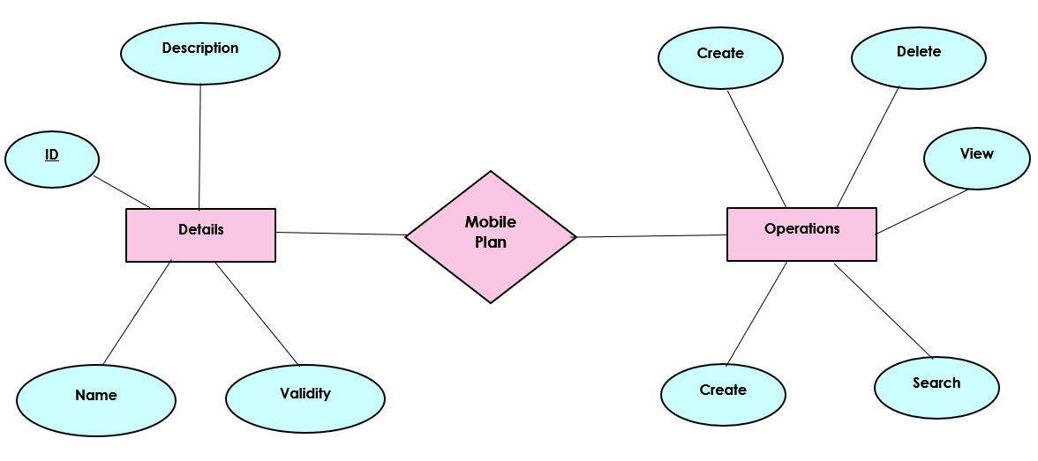

1. Use Case Diagram

1. Architectural Diagram

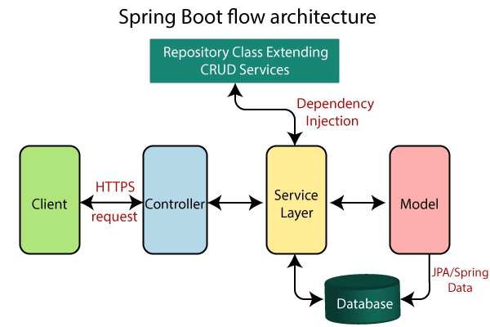

* **SCREENSHOTS:**

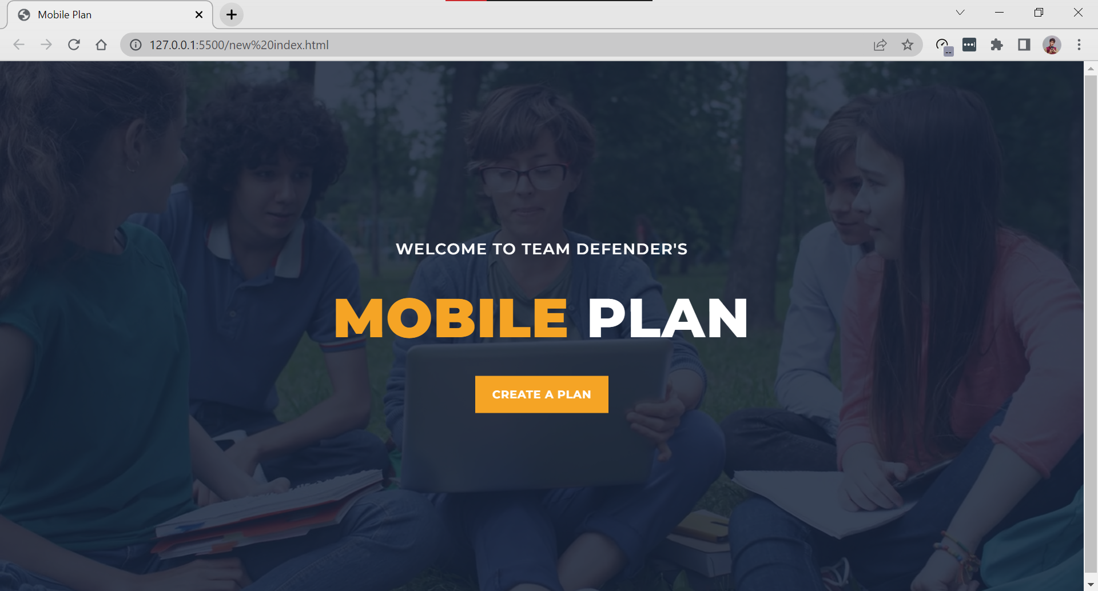

Home Page

To Create a Mobile Plan

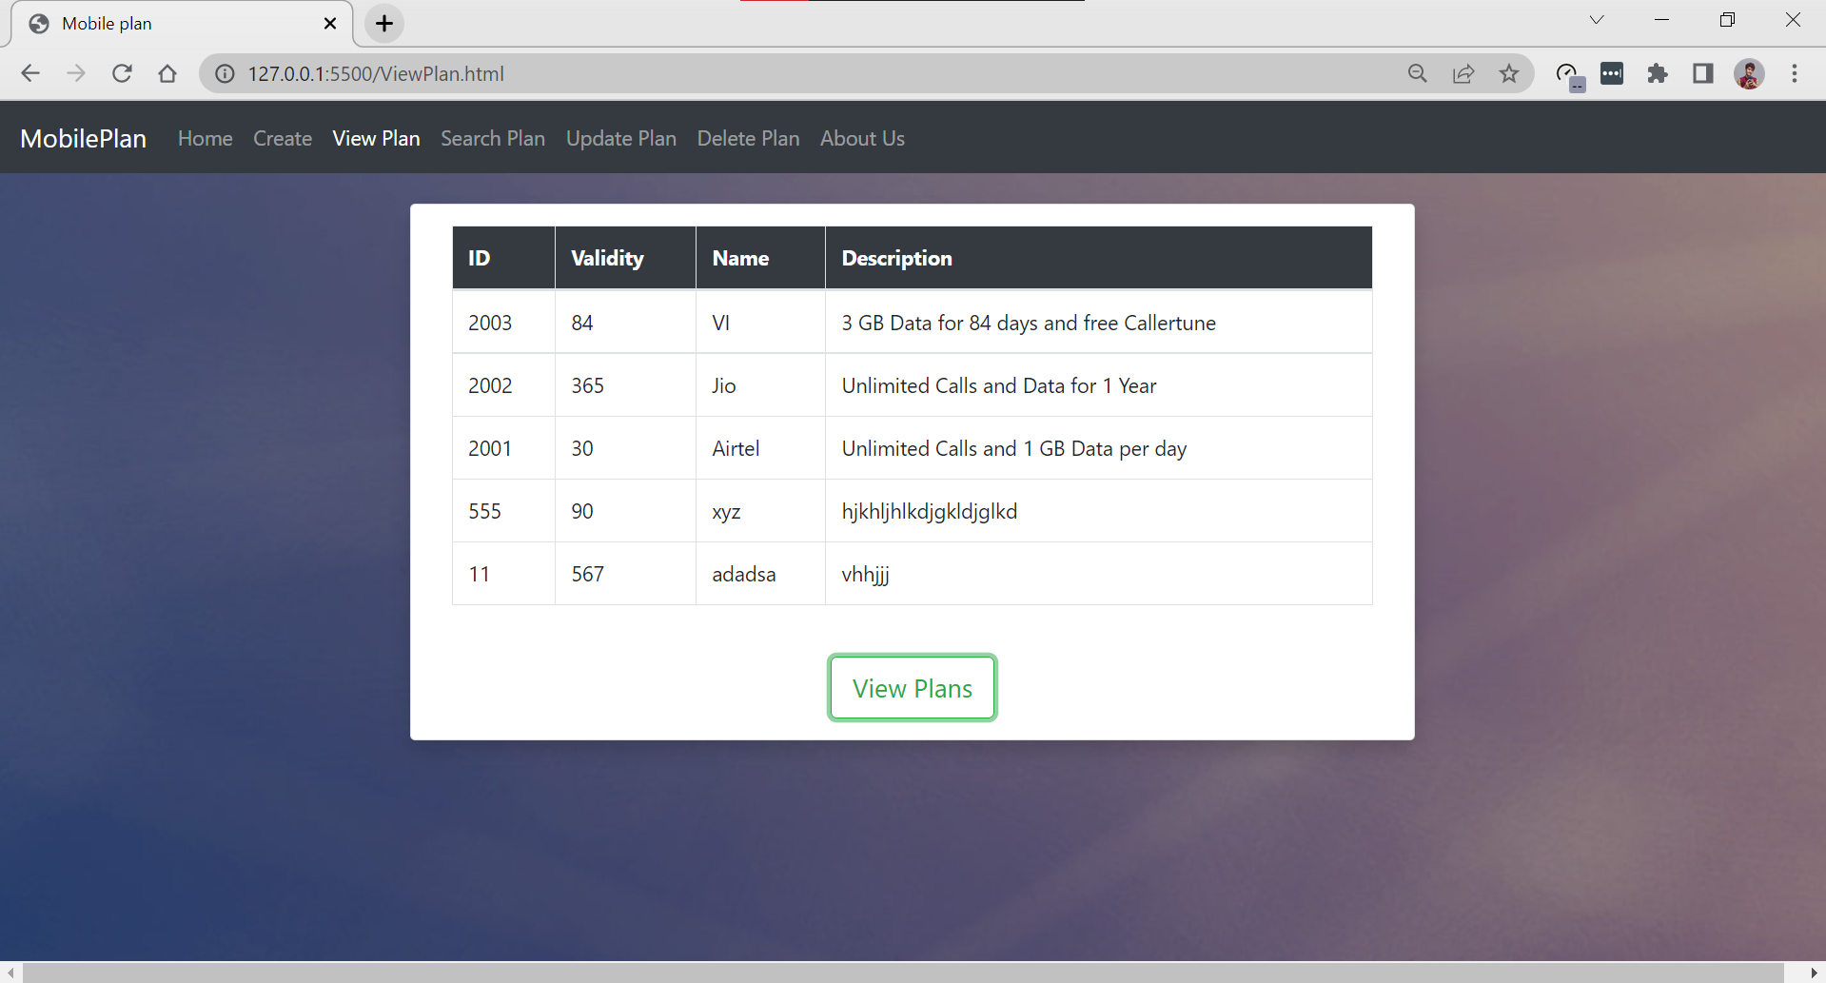

To View all Mobile Plans

Search a Mobile Plan by ID

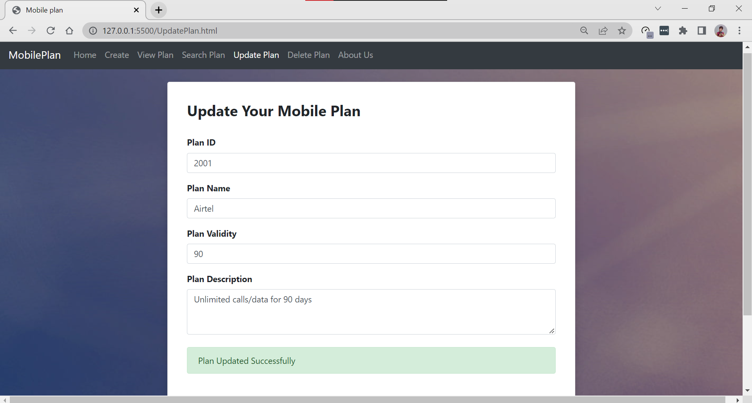

Update Existing Mobile Plan

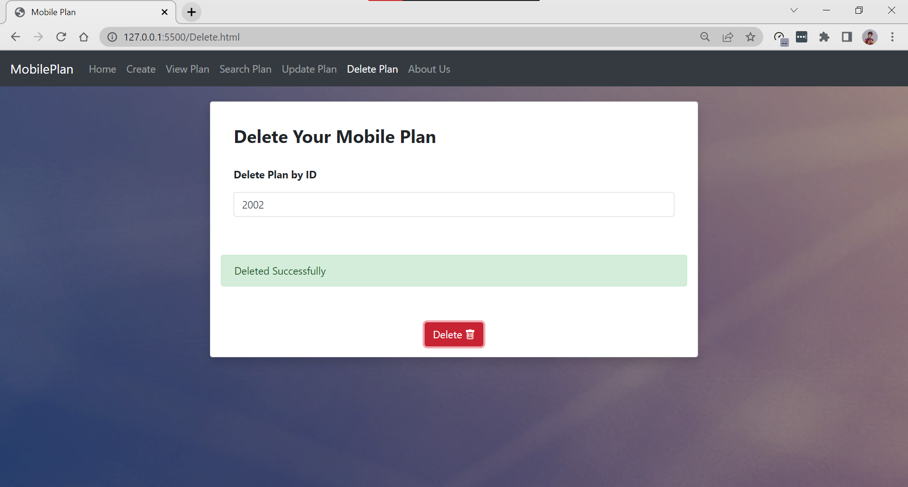

Delete Mobile Plan by ID

­­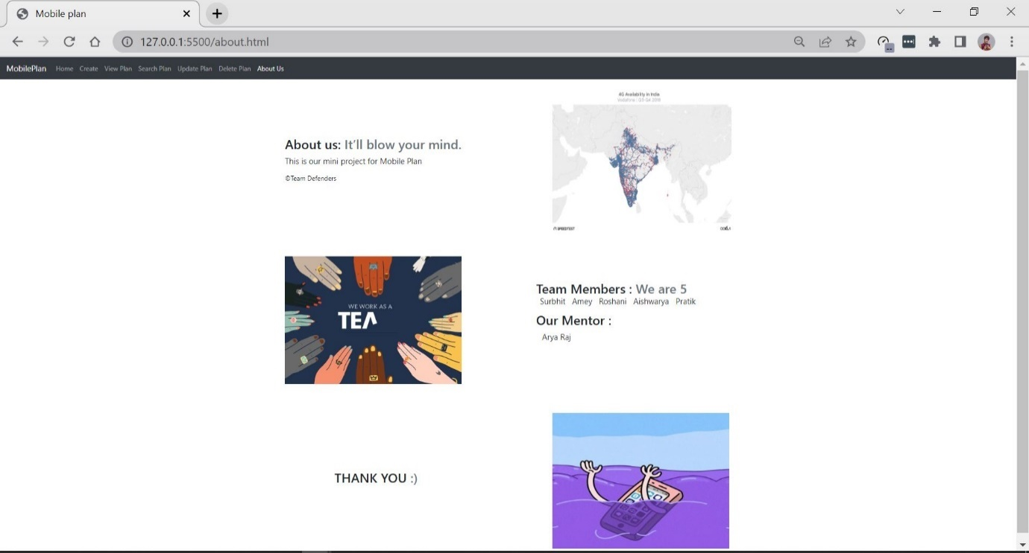

About Us